**Module 4 – Spring Rest**

1. **Create a Spring Web Project using Maven**

package com.cognizant.spring_learn;

import org.slf4j.Logger;

import org.slf4j.LoggerFactory;

import org.springframework.boot.SpringApplication;

import org.springframework.boot.autoconfigure.SpringBootApplication;

@SpringBootApplication

public class SpringLearnApplication {

private static final Logger LOGGER = LoggerFactory.getLogger(SpringLearnApplication.class);

public static void main(String[] args) {

LOGGER.info("START");

SpringApplication.run(SpringLearnApplication.class, args);

LOGGER.info("END");

}

}

**Output:**

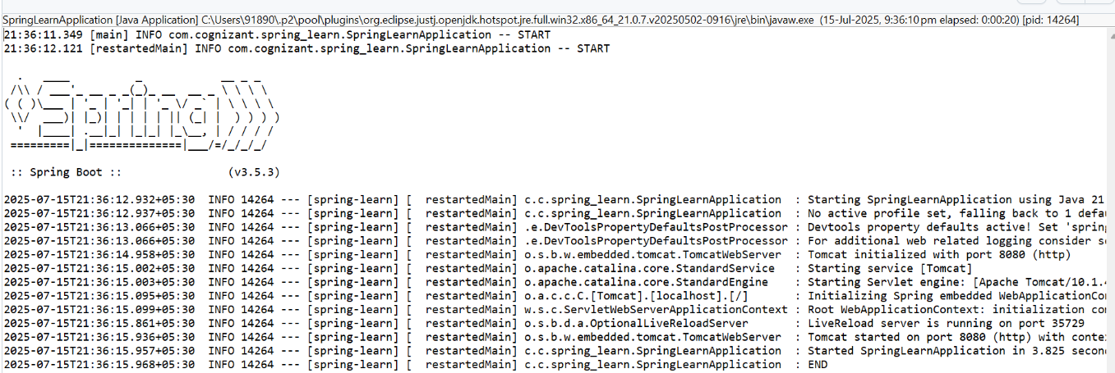

1. **Spring Core – Load Country from Spring Configuration XML**

**Country.java**

package com.cognizant.spring_learn;

import org.slf4j.Logger;

import org.slf4j.LoggerFactory;

public class Country {

private static final Logger LOGGER = LoggerFactory.getLogger(Country.class);

private String code;

private String name;

public Country() {

LOGGER.debug("Inside Country Constructor.");

}

public String getCode() {

LOGGER.debug("Inside getCode()");

return code;

}

public void setCode(String code) {

LOGGER.debug("Inside setCode()");

this.code = code;

}

public String getName() {

LOGGER.debug("Inside getName()");

return name;

}

public void setName(String name) {

LOGGER.debug("Inside setName()");

this.name = name;

}

@Override

public String toString() {

return "Country [code=" + code + ", name=" + name + "]";

}

}

**SpringLearnApplication.java**

package com.cognizant.spring_learn;

import org.slf4j.Logger;

import org.slf4j.LoggerFactory;

import org.springframework.boot.SpringApplication;

import org.springframework.boot.autoconfigure.SpringBootApplication;

import org.springframework.context.ApplicationContext;

import org.springframework.context.support.ClassPathXmlApplicationContext;

@SpringBootApplication

public class SpringLearnApplication {

private static final Logger LOGGER = LoggerFactory.getLogger(SpringLearnApplication.class);

public static void main(String[] args) {

LOGGER.debug("START");

ApplicationContext appContext = SpringApplication.run(SpringLearnApplication.class, args);

displayCountry();

LOGGER.debug("END");

}

public static void displayCountry() {

ApplicationContext context = new ClassPathXmlApplicationContext("country.xml");

Country country = context.getBean("country", Country.class);

LOGGER.debug("Country : {}", country.toString());

}

}

**Pom.xml**

<?xml version="1.0" encoding="UTF-8"?>

<project xmlns="http://maven.apache.org/POM/4.0.0"

xmlns:xsi="http://www.w3.org/2001/XMLSchema-instance"

xsi:schemaLocation="http://maven.apache.org/POM/4.0.0 http://maven.apache.org/xsd/maven-4.0.0.xsd">

<modelVersion>4.0.0</modelVersion>

<parent>

<groupId>org.springframework.boot</groupId>

<artifactId>spring-boot-starter-parent</artifactId>

<version>3.5.3</version>

<relativePath/> <!-- lookup parent from repository -->

</parent>

<groupId>com.cognizant</groupId>

<artifactId>spring-learn</artifactId>

<version>0.0.1-SNAPSHOT</version>

<name>spring-learn</name>

<description>Spring Learn Application</description>

<properties>

<java.version>17</java.version>

</properties>

<dependencies>

<dependency>

<groupId>org.springframework.boot</groupId>

<artifactId>spring-boot-starter-web</artifactId>

</dependency>

<dependency>

<groupId>org.springframework.boot</groupId>

<artifactId>spring-boot-devtools</artifactId>

<scope>runtime</scope>

<optional>true</optional>

</dependency>

</dependencies>

<build>

<plugins>

<plugin>

<groupId>org.springframework.boot</groupId>

<artifactId>spring-boot-maven-plugin</artifactId>

</plugin>

</plugins>

</build>

</project>

**Output:**

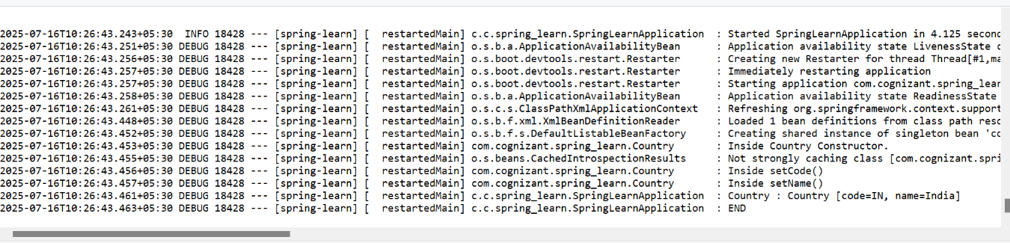

1. **Hello World RESTful Web Service**

**HelloController.java**

package com.cognizant.spring_learn.controller;

import org.slf4j.Logger;

import org.slf4j.LoggerFactory;

import org.springframework.web.bind.annotation.GetMapping;

import org.springframework.web.bind.annotation.RestController;

@RestController

public class HelloController {

private static final Logger LOGGER = LoggerFactory.getLogger(HelloController.class);

@GetMapping("/hello")

public String sayHello() {

LOGGER.debug("Start - sayHello()");

String message = "Hello World!!";

LOGGER.debug("End - sayHello()");

return message;

}

}

**SpringLearnApplication.java**

package com.cognizant.spring_learn;

import org.springframework.boot.SpringApplication;

import org.springframework.boot.autoconfigure.SpringBootApplication;

@SpringBootApplication

public class SpringLearnApplication {

public static void main(String[] args) {

SpringApplication.run(SpringLearnApplication.class, args);

}

}

**Output:**

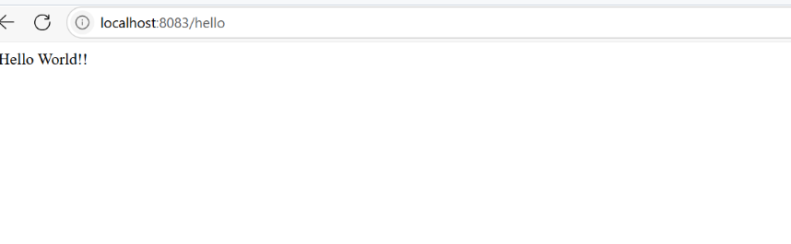

1. **REST - Country Web Service**

**CountryController.java**

package com.cognizant.spring_learn.controller;

import org.springframework.web.bind.annotation.RequestMapping;

import org.springframework.web.bind.annotation.RestController;

import com.cognizant.spring_learn.Country;

import org.springframework.context.ApplicationContext;

import org.springframework.context.support.ClassPathXmlApplicationContext;

import org.slf4j.Logger;

import org.slf4j.LoggerFactory;

@RestController

public class CountryController {

private static final Logger LOGGER = LoggerFactory.getLogger(CountryController.class);

@RequestMapping("/country")

public Country getCountryIndia() {

LOGGER.debug("START - getCountryIndia()");

ApplicationContext context = new ClassPathXmlApplicationContext("country.xml");

Country country = context.getBean("country", Country.class);

LOGGER.debug("Country : {}", country);

LOGGER.debug("END - getCountryIndia()");

return country;

}

}

**SpringLearnApplication.java**

/*package com.cognizant.spring_learn;

import org.slf4j.Logger;

import org.slf4j.LoggerFactory;

import org.springframework.boot.SpringApplication;

import org.springframework.boot.autoconfigure.SpringBootApplication;

import org.springframework.context.ApplicationContext;

import org.springframework.context.support.ClassPathXmlApplicationContext;

@SpringBootApplication

public class SpringLearnApplication {

private static final Logger LOGGER = LoggerFactory.getLogger(SpringLearnApplication.class);

public static void main(String[] args) {

LOGGER.debug("START");

ApplicationContext appContext = SpringApplication.run(SpringLearnApplication.class, args);

displayCountry();

LOGGER.debug("END");

}

public static void displayCountry() {

// Load XML bean definition from country.xml

ApplicationContext context = new ClassPathXmlApplicationContext("country.xml");

Country country = context.getBean("country", Country.class);

LOGGER.debug("Country : {}", country.toString());

}

}

*/

package com.cognizant.spring_learn;

import org.springframework.boot.SpringApplication;

import org.springframework.boot.autoconfigure.SpringBootApplication;

@SpringBootApplication

public class SpringLearnApplication {

public static void main(String[] args) {

SpringApplication.run(SpringLearnApplication.class, args);

}

}

**Output:**

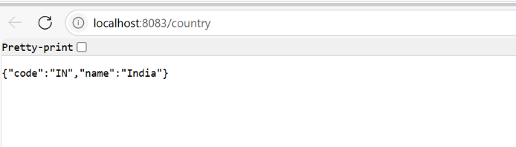

1. **REST - Get country based on country code**

**CountryController.java**

package com.cognizant.spring_learn.controller;

import org.springframework.web.bind.annotation.RestController;

import org.springframework.web.bind.annotation.RequestMapping;

import org.springframework.web.bind.annotation.GetMapping;

import com.cognizant.spring_learn.Country;

import org.springframework.context.ApplicationContext;

import org.springframework.context.support.ClassPathXmlApplicationContext;

import java.util.List;

import org.slf4j.Logger;

import org.slf4j.LoggerFactory;

@RestController

public class CountryController {

private static final Logger LOGGER = LoggerFactory.getLogger(CountryController.class);

@RequestMapping("/country")

public Country getCountryIndia() {

LOGGER.debug("START - getCountryIndia()");

ApplicationContext context = new ClassPathXmlApplicationContext("country.xml");

Country country = context.getBean("country", Country.class);

LOGGER.debug("Country : {}", country);

LOGGER.debug("END - getCountryIndia()");

return country;

}

@GetMapping("/countries")

public List<Country> getAllCountries() {

LOGGER.debug("START - getAllCountries()");

ApplicationContext context = new ClassPathXmlApplicationContext("country.xml");

List<Country> countries = context.getBean("countryList", List.class);

LOGGER.debug("Countries: {}", countries);

LOGGER.debug("END - getAllCountries()");

return countries;

}

}

**SpringLearnApplication.java**

package com.cognizant.spring_learn;

import org.slf4j.Logger;

import org.slf4j.LoggerFactory;

import org.springframework.boot.SpringApplication;

import org.springframework.boot.autoconfigure.SpringBootApplication;

import org.springframework.context.ApplicationContext;

import org.springframework.context.support.ClassPathXmlApplicationContext;

@SpringBootApplication

public class SpringLearnApplication {

private static final Logger LOGGER = LoggerFactory.getLogger(SpringLearnApplication.class);

public static void main(String[] args) {

SpringApplication.run(SpringLearnApplication.class, args);

LOGGER.debug("START");

displayCountry();

LOGGER.debug("END");

}

public static void displayCountry() {

ApplicationContext context = new ClassPathXmlApplicationContext("country.xml");

Country country = context.getBean("country", Country.class);

LOGGER.debug("Country : {}", country.toString());

}

}

**Country.xml**

<?xml version="1.0" encoding="UTF-8"?>

<beans xmlns="http://www.springframework.org/schema/beans"

xmlns:xsi="http://www.w3.org/2001/XMLSchema-instance"

xsi:schemaLocation="http://www.springframework.org/schema/beans

http://www.springframework.org/schema/beans/spring-beans.xsd">

<bean id="country" class="com.cognizant.spring_learn.Country">

<property name="code" value="IN"/>

<property name="name" value="India"/>

</bean>

<bean id="countryList" class="java.util.ArrayList">

<constructor-arg>

<list>

<bean class="com.cognizant.spring_learn.Country">

<property name="code" value="IN"/>

<property name="name" value="India"/>

</bean>

<bean class="com.cognizant.spring_learn.Country">

<property name="code" value="US"/>

<property name="name" value="United States"/>

</bean>

<bean class="com.cognizant.spring_learn.Country">

<property name="code" value="JP"/>

<property name="name" value="Japan"/>

</bean>

<bean class="com.cognizant.spring_learn.Country">

<property name="code" value="DE"/>

<property name="name" value="Germany"/>

</bean>

</list>

</constructor-arg>

</bean>

</beans>

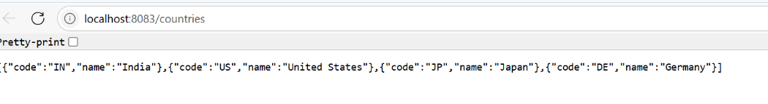**Output:**